Imperial System
# Source: AI Source: Provided by: [Data Path: Persons Table -> ID Column: 1, Name_En Column: Motasem Essam] -> From: [ChatGPT] on [7/17/2026]
The Imperial System (also called the British Imperial System) is a non-metric measurement system established in the United Kingdom by the Weights and Measures Act of 1824. It standardized many traditional English units of length, mass, volume, and area into a single national system.
Although the International System of Units (SI) has replaced the Imperial System for most scientific and commercial purposes, several Imperial units remain in use, particularly in the United Kingdom and in specific industries such as aviation and maritime navigation.

Definition
# Source: AI Source: Provided by: [Data Path: Persons Table -> ID Column: 1, Name_En Column: Motasem Essam] -> From: [ChatGPT] on [7/17/2026]
The Imperial System is a standardized system of measurement based on traditional British units for measuring physical quantities such as length, mass, volume, area, and temperature.
Unlike the Metric System, the Imperial System is not decimal-based. Most unit conversions use factors such as 12, 3, 16, 20, 8, and 1760 rather than powers of ten.

History
# Source: AI Source: Provided by: [Data Path: Persons Table -> ID Column: 1, Name_En Column: Motasem Essam] -> From: [ChatGPT] on [7/17/2026]
The Imperial System was created to unify the many different measurement standards used throughout Britain.
Key milestones:
- 1824 – Established by the Weights and Measures Act in the United Kingdom.
- 1835 – Adoption became mandatory in Britain.
- 1965 onward – The United Kingdom gradually began metrication.
- Today – Imperial units remain in limited everyday and specialized use.

Characteristics
# Source: AI Source: Provided by: [Data Path: Persons Table -> ID Column: 1, Name_En Column: Motasem Essam] -> From: [ChatGPT] on [7/17/2026]
The Imperial System is:
- Non-metric.
- Non-decimal.
- Based on traditional British units.
- Standardized by law in 1824.
- Historically important in trade, engineering, and navigation.

Common Quantities Measured
# Source: AI Source: Provided by: [Data Path: Persons Table -> ID Column: 1, Name_En Column: Motasem Essam] -> From: [ChatGPT] on [7/17/2026]
The Imperial System includes units for:
- Length
- Distance
- Area
- Volume
- Capacity
- Mass
- Weight
- Temperature
- Speed
- Pressure

Units of Length
# Source: AI Source: Provided by: [Data Path: Persons Table -> ID Column: 1, Name_En Column: Motasem Essam] -> From: [ChatGPT] on [7/17/2026]
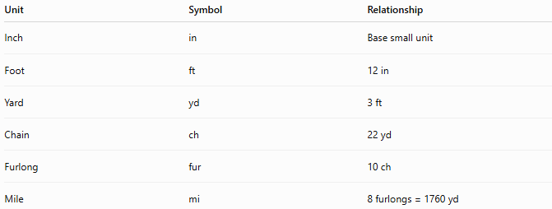
Unit | Symbol | Relationship
Inch | in | Base small unit
Foot | ft | 12 in
Yard | yd | 3 ft
Chain | ch | 22 yd
Furlong | fur | 10 ch
Mile | mi | 8 furlongs = 1760 yd

Units of Area
# Source: AI Source: Provided by: [Data Path: Persons Table -> ID Column: 1, Name_En Column: Motasem Essam] -> From: [ChatGPT] on [7/17/2026]

Unit | Relationship
Square inch | in²
Square foot | ft²
Square yard | yd²
Acre | 4,840 yd²
Square mile | 640 acres

Units of Volume
# Source: AI Source: Provided by: [Data Path: Persons Table -> ID Column: 1, Name_En Column: Motasem Essam] -> From: [ChatGPT] on [7/17/2026]

Unit | Relationship
Cubic inch | in³
Cubic foot | ft³
Cubic yard | yd³

Units of Capacity
# Source: AI Source: Provided by: [Data Path: Persons Table -> ID Column: 1, Name_En Column: Motasem Essam] -> From: [ChatGPT] on [7/17/2026]
Imperial capacity measures liquids and some dry materials.
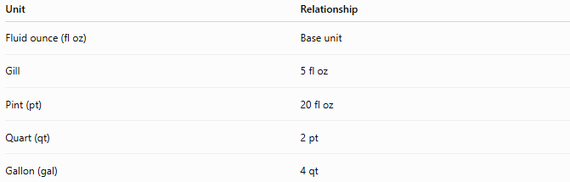
Unit | Relationship
Fluid ounce (fl oz) | Base unit
Gill | 5 fl oz
Pint (pt) | 20 fl oz
Quart (qt) | 2 pt
Gallon (gal) | 4 qt
Note: The Imperial gallon is different from the U.S. gallon.

Units of Mass (Weight)
# Source: AI Source: Provided by: [Data Path: Persons Table -> ID Column: 1, Name_En Column: Motasem Essam] -> From: [ChatGPT] on [7/17/2026]
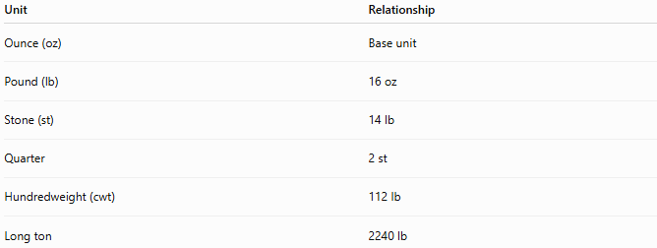
Unit | Relationship
Ounce (oz) | Base unit
Pound (lb) | 16 oz
Stone (st) | 14 lb
Quarter | 2 st
Hundredweight (cwt) | 112 lb
Long ton | 2240 lb

Units of Temperature
# Source: AI Source: Provided by: [Data Path: Persons Table -> ID Column: 1, Name_En Column: Motasem Essam] -> From: [ChatGPT] on [7/17/2026]
Historically, the Imperial System commonly uses:
- Degree Fahrenheit (°F)
Although the United Kingdom now officially uses degrees Celsius (°C) for most purposes.

Examples
# Source: AI Source: Provided by: [Data Path: Persons Table -> ID Column: 1, Name_En Column: Motasem Essam] -> From: [ChatGPT] on [7/17/2026]
Example 1
Length
$$6\text{ ft}$$

Example 2
Distance
$$10\text{ mi}$$

Example 3
Weight
$$150\text{ lb}$$

Example 4
Capacity
$$2\text{ gal}$$

Advantages
# Source: AI Source: Provided by: [Data Path: Persons Table -> ID Column: 1, Name_En Column: Motasem Essam] -> From: [ChatGPT] on [7/17/2026]
The Imperial System:
- Has a long historical tradition.
- Remains familiar in some countries.
- Is still used in certain industries.
- Includes practical units for construction and navigation.

Disadvantages
# Source: AI Source: Provided by: [Data Path: Persons Table -> ID Column: 1, Name_En Column: Motasem Essam] -> From: [ChatGPT] on [7/17/2026]
The Imperial System:
- Is not decimal-based.
- Has complex conversion factors.
- Is less convenient for scientific calculations.
- Is less widely used internationally.
- Requires more memorization than the Metric System.

Applications
# Source: AI Source: Provided by: [Data Path: Persons Table -> ID Column: 1, Name_En Column: Motasem Essam] -> From: [ChatGPT] on [7/17/2026]
Imperial units are still used in:
- Construction
- Architecture
- Road signs (United Kingdom: miles)
- Aviation (altitude in feet)
- Maritime navigation
- Body height (feet and inches)
- Some engineering fields
- Historical documents

Everyday Examples
# Source: AI Source: Provided by: [Data Path: Persons Table -> ID Column: 1, Name_En Column: Motasem Essam] -> From: [ChatGPT] on [7/17/2026]
Imperial units are commonly encountered when:
- Measuring a person's height in feet and inches.
- Expressing road distances in miles (United Kingdom).
- Measuring aircraft altitude in feet.
- Recording body weight in stones and pounds (United Kingdom).
- Purchasing some beverages in pints.

Common Mistakes
# Source: AI Source: Provided by: [Data Path: Persons Table -> ID Column: 1, Name_En Column: Motasem Essam] -> From: [ChatGPT] on [7/17/2026]
- Confusing Imperial units with United States Customary units.
- Assuming Imperial units are decimal-based.
- Using the wrong gallon (Imperial vs. U.S.).
- Mixing Imperial and SI units without conversion.

Key Points
# Source: AI Source: Provided by: [Data Path: Persons Table -> ID Column: 1, Name_En Column: Motasem Essam] -> From: [ChatGPT] on [7/17/2026]
- The Imperial System was established in 1824.
- It is a non-metric measurement system.
- It uses traditional British units.
- It is not decimal-based.
- It has been largely replaced by the SI system but remains in limited use.

Imperial System vs. SI System
# Source: AI Source: Provided by: [Data Path: Persons Table -> ID Column: 1, Name_En Column: Motasem Essam] -> From: [ChatGPT] on [7/17/2026]
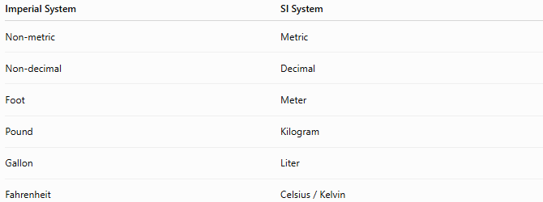
Imperial System | SI System
Non-metric | Metric
Non-decimal | Decimal
Foot | Meter
Pound | Kilogram
Gallon | Liter
Fahrenheit | Celsius / Kelvin

Imperial System vs. Metric System
# Source: AI Source: Provided by: [Data Path: Persons Table -> ID Column: 1, Name_En Column: Motasem Essam] -> From: [ChatGPT] on [7/17/2026]

Imperial | Metric
Inch | Centimeter
Foot | Meter
Mile | Kilometer
Pound | Kilogram
Gallon | Liter

Imperial System vs. United States Customary System
# Source: AI Source: Provided by: [Data Path: Persons Table -> ID Column: 1, Name_En Column: Motasem Essam] -> From: [ChatGPT] on [7/17/2026]
Although the two systems share many unit names, they are not identical.
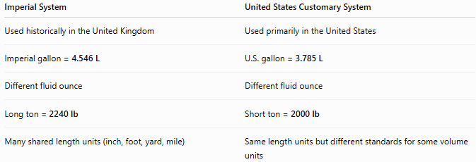
Imperial System | United States Customary System
Used historically in the United Kingdom | Used primarily in the United States
Imperial gallon = 4.546 L | U.S. gallon = 3.785 L
Different fluid ounce | Different fluid ounce
Long ton = 2240 lb | Short ton = 2000 lb
Many shared length units (inch, foot, yard, mile) | Same length units but different standards for some volume units

Conclusion
# Source: AI Source: Provided by: [Data Path: Persons Table -> ID Column: 1, Name_En Column: Motasem Essam] -> From: [ChatGPT] on [7/17/2026]
The Imperial System is a non-metric measurement system established in the United Kingdom in 1824 to standardize traditional British units. It includes units such as the inch, foot, yard, mile, pound, stone, pint, and gallon, and has historically been used in commerce, engineering, navigation, and everyday life. Although it has largely been replaced by the International System of Units (SI), many Imperial units remain in use, especially in the United Kingdom and in specialized fields such as aviation, maritime navigation, and construction.

